Đoạn code điều khiển, cái mà cần phải biết để chỉnh sửa lại theo ý của mình.  
  
;================================================= ===========  
; TP RELAYS ON PORT 0 DTMF ON PORT 1  
; STATUS ON PORT 2  
; ================================================== =========  
  
;$MOD51  
  
LED EQU P1.7  
TONE_D EQU P3.6  
TONE_B EQU P3.4  
REL1 EQU P3.0 ; LINE CHANGE-OVER RELAY  
REL2 EQU P3.1 ; RINGING RELAY  
MELODY EQU P3.7 ; UM66T MELODY GENRATOR  
ZERO EQU 10  
F10 BIT 78H ; BIT FLAG  
F11 BIT 79H  
Ph BIT 7AH  
  
On_Hook MACRO ; HOOK SWITCH ON P1.6  
SETB P1.6  
ENDM  
  
Off_Hook MACRO ; HOOK SWITCH ON P1.6  
CLR P1.6  
ENDM  
  
  
;================================================= ============  
; INTERRUPT VECTOR TABLE  
;================================================= ============  
  
ORG 00H ; ENTRY ADDRESS FOR 89C51 RESET  
AJMP MAIN ; MAIN STARTS BEYOND INTERRUPT VECTOR SPACE  
  
ORG 1BH ; VECTOR ADDRESS FOR INTERRUPT  
SETB Ph ; MARK "THIS IS A PHONE CALL"  
AJMP PHONE ; JUMP TO PHONE CALL SERVICE  
  
  
;================================================= ============  
; M A I N  
;================================================= ============  
  
ORG 02CH ; START BEYOND THE VECTOR TABLE  
MAIN:  
ACALL INITIALIZE_SUB ; INITILIZE CONTRO RAGISTER(TMOD & IE)  
START:  
CLR LED  
ACALL SCAN_TPs  
JB F10,INTERCOM  
  
SETB LED  
ACALL SCAN_TPs  
JB F10,INTERCOM  
  
AJMP START  
  
  
;================================================= ===========  
; INTERCOM SERVICE  
;================================================= ===========  
  
INTERCOM:  
CLR F10 ; RESET FLAG  
Off_Hook ; DISABLE PHONE CALL  
SETB TONE_D ; ON DIAL TONE  
SETB TONE_B ; ON BUSY TONE  
CLR LED ; ON LED PERMANENTLY  
CPL A  
MOV P0,A ; CONNECT SCANED No. TO SPEACH-BUS  
  
ACALL GET_DIAL_NUM ; GET NUMBER TO CALL  
  
CJNE A,#0FFH,INTERNAL ; IF DIAL=FF THEN PHONE CALL FROM INTERCOM  
CLR REL1 ; CONNECT SPEACH-BUS TO PHONE LINE  
Off_Hook ; OFF-HOOK SYSTEM  
CLR LED ; ON LED PERMANENTLY  
AJMP EXTERNAL_CALL  
  
INTERNAL:  
MOV R3,A ; SAVE SUBSCRIBER No. INTO R3  
ANL A,P0  
MOV P0,A ; CONNECT DIALED No. TO SPEACH-BUS  
  
MOV A,R3 ; PROCESSING FOR CHECKING SUBSCRIBER  
ANL A,P2 ; AND SUBCRIBER WITH CALLER  
  
ACALL BELL ; RING THE BELL  
EXTERNAL_CALL:  
ACALL DELAY_HS  
  
SPEACH: MOV A,P2  
CJNE A,#255,SPEACH ; IF CALL COMPLETE THEN RESET SYSTEM  
ACALL RST_SYSTEM ; ELSE WAIT HERE  
AJMP START  
  
  
;================================================= ===========  
;THIS ROUTINE CHECKED TP'S STATUS IF ANY OFF_HOOK FOUND SERVICE  
;PROVIDED HIM  
;================================================= ===========  
  
SCAN_TPs: ; FLASHING LED WITH SCANING TPs  
MOV R0,#76  
LOOP: MOV R1,#250  
  
_1: MOV A,#1 ; START POINTER WITH ONE  
JB P2.0,_2  
SETB F10  
AJMP OUT  
  
_2: RL A  
JB P2.1,_3  
SETB F10  
AJMP OUT  
  
_3: RL A  
JB P2.2,_4  
SETB F10  
AJMP OUT  
  
_4: RL A  
JB P2.3,_5  
SETB F10  
AJMP OUT  
  
_5: RL A  
JB P2.4,_6  
SETB F10  
AJMP OUT  
  
_6: RL A  
JB P2.5,_7  
SETB F10  
AJMP OUT  
  
_7: RL A  
JB P2.6,_8  
SETB F10  
AJMP OUT  
  
_8: RL A  
JB P2.7,BACK  
SETB F10  
AJMP OUT  
  
BACK: DJNZ R1,_1  
DJNZ R0,LOOP  
OUT: RET ; RETURN FROM SUB ROUTINE  
  
  
;================================================= ===========  
; THIS ROUTINE RINGING THE BELL ON DIALED NUMBER  
;================================================= ===========  
  
BELL:  
CLR TONE_D ; OFF DIAL TONE  
CLR REL2 ; ON BELL RELAY  
ACALL DELAY ; RING BELL FOR ONE MINIT  
SETB REL2 ; OFF BELL RELAY  
  
ACALL DELAY  
JB F10,RET1  
ACALL DELAY1  
JB F10,RET1  
ACALL DELAY1  
JB F10,RET1  
AJMP BELL  
RET1: RET  
  
  
;================================================= ===========  
; CHECK TELEPHONE'S STATUS UPTO ONE SECOND  
; IF PIKED UP THEN SET FLAG  
;================================================= ===========  
  
DELAY1: ; ONE SECOND DELAY WITH STATUS CHECKING  
MOV R0,#4  
LOOP11: MOV R1,#250  
LOOP12: MOV R2,#250  
LOOP13: CJNE A,P2,NOT_EQ  
SETB F10 ; MARK SUBSCRIBER READY TO TALK  
AJMP RET2  
NOT_EQ: DJNZ R2,LOOP13  
DJNZ R1,LOOP12  
DJNZ R0,LOOP11  
RET2: RET  
  
  
;================================================= ===========  
; ONE SECOND DELAY  
;================================================= ===========  
  
DELAY: ; ONE SECOND DELAY  
MOV R0,#4  
LOOP1: MOV R1,#250  
LOOP2: MOV R2,#250  
LOOP3: NOP  
NOP  
DJNZ R2,LOOP3  
DJNZ R1,LOOP2  
DJNZ R0,LOOP1  
RET  
  
  
;================================================= ===========  
; READ DIALED NUMBER,RE-CHECK IF 0, * OR #  
;================================================= ===========  
  
GET_DIAL_NUM:  
JNB P1.4,$ ; WAIT FOR KEY PRESS (STROB)  
MOV A,P1 ; READ DIALED NUMBER  
ANL A,#00001111B ; REMOVE EXTRA BITS  
  
CJNE A,#ZERO,STERIK ;  
JB Ph,GET_DIAL_NUM ; IF ZERO FROM PHONE CALL THEN READ AGAIN  
MOV A,#0FFH ; TRUNK CALL FROM INTERCOM  
AJMP RET3  
  
STERIK: CJNE A,#11,HASH ; IF STERIK, READ AGAIN  
AJMP GET_DIAL_NUM  
  
HASH: CJNE A,#12,NINE ; IF HASH, READ AGAIN  
AJMP GET_DIAL_NUM  
  
NINE: CJNE A,#9,DECODE  
JNB Ph,GET_DIAL_NUM ; DIAL=9 & NOT A PHONE THEN READ AGAIN  
MOV A,#252 ; SELECT TO ALL (VIRTUALY 8)  
AJMP RET3  
  
DECODE: DEC A  
MOV R1,A  
MOV A,#1  
ROTATE: RL A  
DJNZ R1,ROTATE  
CPL A  
RET3: RET  
  
  
;================================================= ============  
; RESET ALL SYSTEM  
;================================================= ============  
  
RST_SYSTEM:  
CLR TONE_D ; OFF DIAL-TONE  
CLR TONE_B ; OFF BUSY-TONE  
CLR F10 ; RESET FLAG  
CLR Ph ; CLEAR PHONE CALL FLAG  
CLR F11  
MOV P0,#255 ; OFF ALL TPs RELAYS  
SETB REL1 ; OFF CHANGE-OVER RELAY  
SETB TR1 ; START TIMER/COUNTER  
On_Hook ; ENABLE PHONE CALL  
RET  
  
  
;================================================= ===========  
; INITIALIZE SYSTEM  
;================================================= ===========  
  
INITIALIZE_SUB: ; SET UP CONTROL REGISTERS  
MOV TMOD, #01100000B ; TIMER 1 IS SET FOR MODE 2, COUNTER OPERATION  
MOV IE, #10001000B ; ENABLE TIMER/COUNTER 1 INTERRUPT  
MOV TH1, #219 ; AUTO RELOAD VALUE(INT1 TL1) EACH TIME AFTER OVERFLOW.  
MOV TL1, #219 ; DEMO TIMER IS INITIALISED WITH (256-39=217)  
; TO COUNT 39(2BELL)EVENTS  
CLR TONE_D ; OFF DIAL-TONE  
CLR TONE_B ; OFF BUSY-TONE  
SETB TR1 ; START COUNTER 1  
RET  
  
  
;================================================= ============  
; PHONE CALL SERVICE  
;================================================= ============  
  
PHONE:  
CLR TR1 ; STOP TIMER1  
Off_Hook ; OFF-HOOK SYSTEM  
CLR LED ; ON LED PERMANENTLY  
ACALL UM66 ; PLAY MELODY  
  
CLR REL1 ; CONNECT SPEACH-BUS TO PHONE LINE  
NEXT: ACALL GET_DIAL_NUM ; GET NUMBER TO CALL  
SETB REL1 ; DISCONNECT FOR BELL  
  
MOV P0,A ; CONNECT DIALED No. TO SPEACH-BUS  
ACALL BELL ; RING THE BELL  
CLR REL1 ; CONNECT SPEACH-BUS TO PHONE LINE  
ACALL DELAY_HS ; PROVIDE HALF SECOND DELAY  
  
BUSY: MOV A,P2  
CJNE A,#255,BUSY ; IF CALL NOT COMPLETE, WAIT ARROUND HERE  
  
JB F11,RESET ; CHECK FOR SECOND CALL  
MOV P0,#255 ; DISCONNECT ALL TELEPHONES  
SETB TONE_B ; ON BUSY TONE  
SETB F11 ; MARK FOR SECOND PHONE CALL  
CLR F10 ; RESET FLAG  
AJMP NEXT ; GO FOR NEXT PHONE CALL  
  
RESET: ACALL RST_SYSTEM ; END CALL  
RETI  
  
  
;================================================= ==================  
; PLAY MELODY (UM66)  
;================================================= ==================  
  
UM66: CLR MELODY ; PLAY MELODY AS GREETING MESSAGE  
ACALL DELAY ; FOR FIVE SECOND  
ACALL DELAY  
ACALL DELAY  
ACALL DELAY  
ACALL DELAY  
SETB MELODY ; STOP MELODY  
RET  
  
  
;================================================= ===================  
; HALF SECOND DELAY TO ESTABLISHED THE RELAY CONTECTS  
;================================================= ===================  
  
DELAY_HS: ; HALF SECOND DELAY  
MOV R0,#2  
LOOP21: MOV R1,#250  
LOOP22: MOV R2,#250  
LOOP23: NOP  
NOP  
DJNZ R2,LOOP23  
DJNZ R1,LOOP22  
DJNZ R0,LOOP21  
RET  
  
END

Attached Files

* [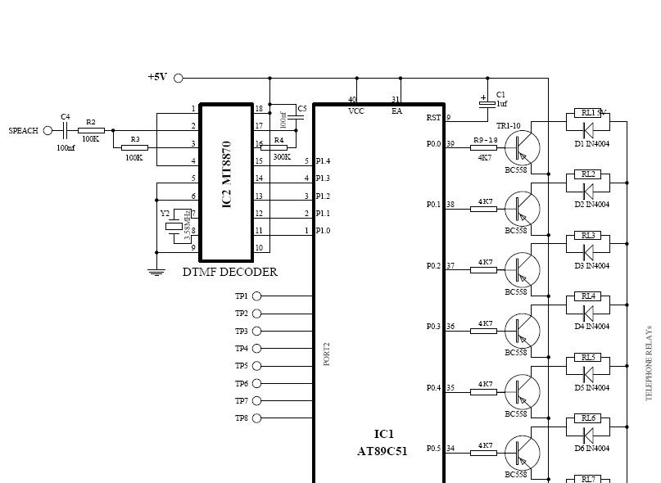](http://www.dientuvietnam.net/forums/filedata/fetch?id=1326965)

chi đâu mà khó khăn ghê rứa choy , cái này k bit có đáp ứng đc nhu cầu mấy pro ko nữa . Chỉ cần dùng con MT8870 là nhận tín hiệu vô tư oy mà .  
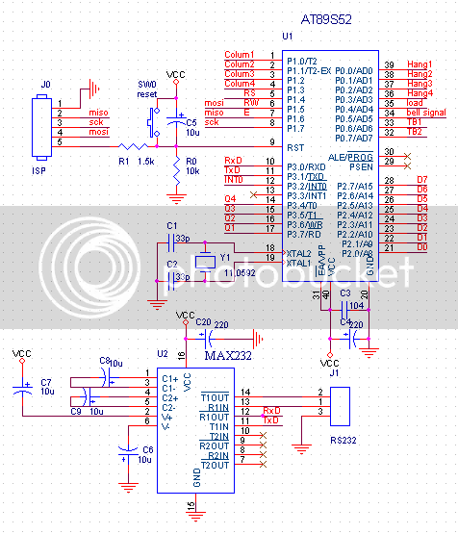  
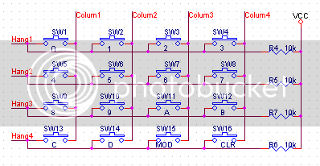  
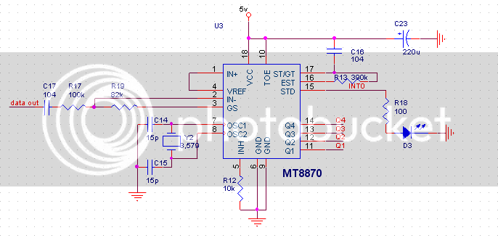  
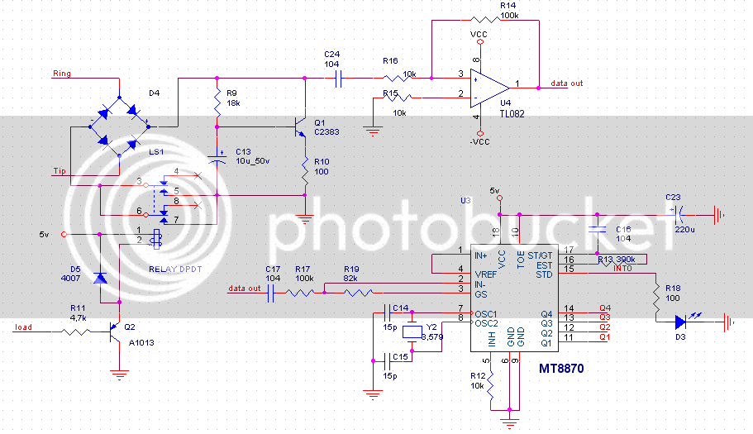  
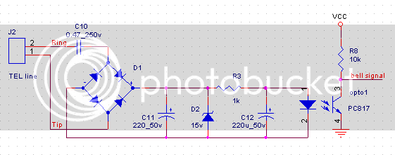  
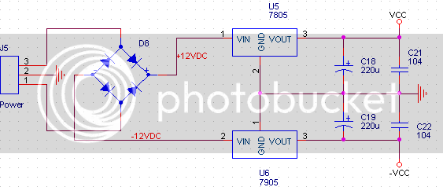  
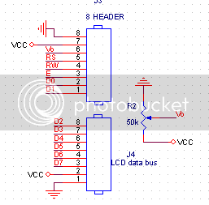  
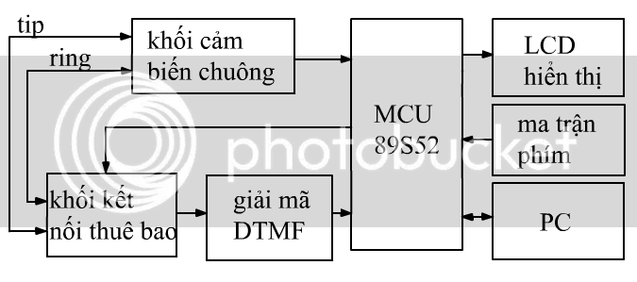  
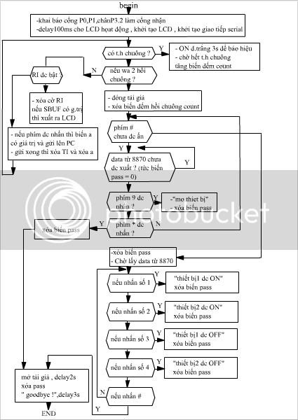  
  
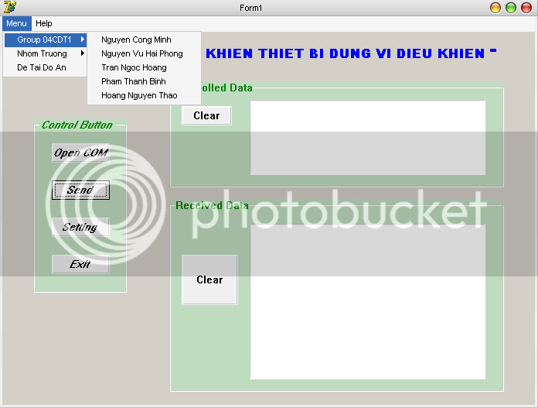  
  
chương trình đơn giản , cho mấy ku bạn hỉu để bảo vệ thực tập VDK

Code:

#include<AT89S53.h>

sbit RS = 0x94; // RS = P1_4

sbit RW = 0x95; // RW = P1_5

sbit E = 0x96; // E = P1_6

sbit load = 0x84; // role = P0_4

sbit bell_signal = 0x85; // tin hieu chuong

sbit green = 0x86; // TB1 = P0_6

sbit red = 0x87; // TB1 = P0_7

sbit STD = 0xB2; // P3_2

unsigned char count = 0 ; // bien dem hoi chuong

unsigned char a = 0 ; // bien dem cac so nhap tu ban phim de truyen len PC

unsigned char pass = 0 ; // bien lay data tu 8870

void delay_ms( unsigned int ms )

{ unsigned int i,j;

for (i=0;i<ms;i++)

for (j=0;j<120;j++){};

}

void LCD_PutChar(unsigned char k )

{ P2=k ; RS=1 ; RW=0 ; E=1 ; E=0 ; delay_ms(1);}

void LCD_PutCmd(unsigned char k )

{ P2=k ; RS=0 ; RW=0 ; E=1 ; E=0 ; delay_ms(3);}

void int_LCD()

{

LCD_PutCmd(0x38) ;

LCD_PutCmd(0x0C) ;

LCD_PutCmd(0x06) ;

LCD_PutCmd(0x01) ;

}

void quetphim_hienthi()

{

P1_0=0;P1_1=P1_2=P1_3=1;

if (P0_0==0) { delay_ms(50);

while(P0_0==0) continue ;

delay_ms(20);

LCD_PutChar('0');a = '0';

} ;

if (P0_1==0) { delay_ms(50);

while(P0_1==0) continue ;

delay_ms(20);

LCD_PutChar('4');a = '4';

} ;

if (P0_2==0) { delay_ms(50);

while(P0_2==0) continue ;

delay_ms(20);

LCD_PutChar('8');a = '8';

} ;

if (P0_3==0) { delay_ms(50);

while(P0_3==0) continue ;

delay_ms(20);

LCD_PutChar('C') ; a = 'C';

} ;

P1_0=P1_2=P1_3=1;P1_1=0;

if (P0_0==0) { delay_ms(50);

while(P0_0==0) continue ;

delay_ms(20);

LCD_PutChar('1');a = '1';

} ;

if (P0_1==0) { delay_ms(50);

while(P0_1==0) continue ;

delay_ms(20);

LCD_PutChar('5'); a = '5';

} ;

if (P0_2==0) { delay_ms(50);

while(P0_2==0) continue ;

delay_ms(20);

LCD_PutChar('9');a = '9';

} ;

if (P0_3==0) { delay_ms(50);

while(P0_3==0) continue ;

delay_ms(20);

LCD_PutChar('D') ;a = 'D';

} ;

P1_0=P1_1=P1_3;P1_2=0;

if (P0_0==0) { delay_ms(50);

while(P0_0==0) continue ;

delay_ms(20);

LCD_PutChar('2'); a = '2';

} ;

if (P0_1==0) { delay_ms(50);

while(P0_1==0) continue ;

delay_ms(20);

LCD_PutChar('6');a = '6';

} ;

if (P0_2==0) { delay_ms(50);

while(P0_2==0) continue ;

delay_ms(20);

LCD_PutChar('A');a = 'A';

} ;

if (P0_3==0) { delay_ms(50);

while(P0_3==0) continue ;

delay_ms(20);

LCD_PutChar('E');a = 'E';

} ;

P1_0=P1_1=P1_2=1;P1_3=0;;

if (P0_0==0) { delay_ms(50);

while(P0_0==0) continue ;

delay_ms(20);

LCD_PutChar('3');a = '3';

} ;

if (P0_1==0) { delay_ms(50);

while(P0_1==0) continue ;

delay_ms(20);

LCD_PutChar('7');a = '7';

} ;

if (P0_2==0) { delay_ms(50);

while(P0_2==0) continue ;

delay_ms(20);

LCD_PutChar('B');a = 'B';

} ;

if (P0_3==0) { delay_ms(50);

while(P0_3==0) continue ;

delay_ms(20);

LCD_PutCmd(0x01) ; // clearscreen

LCD_PutCmd(0x80) ;

a = 0;

} ;

}

void serial_init()

{ TMOD = 0x20; // timer1 mod2 (8bit nap lai)

SCON = 0x50; // che do noi tiep 1(8bit 1bit start 1bit stop)

TH1 = 0xFD; // nap toc do baud = 9600

TR1 = 1; // cho chay timer1

RI = 1; // san sang nhan

TI = 1; // san sang truyen

}

main()

{

P0 = 0xFF ;

P1 = 0xFF ;

STD = 1 ;

delay_ms(100);

int_LCD();

LCD_PutCmd(0x80) ; // gui lenh xuat chu o dong 1 cot 1 of LCD

serial_init();

while(1)

{ quetphim_hienthi();

if(!bell_signal) {green = 0 ; delay_ms(3000);

if(bell_signal)green = 1 ;

count++ ;

}

if (count==2)

{ load = 0 ; // dong tai gia

count = 0 ; // xoa bo dem ve 0

while(pass!=0x30) // phim # - OK

{if(pass==0)

{ while(STD==0) continue ; // wait tin hieu tu 8870

while(STD==1) continue ;

pass = (P3&0xF0); // lay 4 bit cao of P3

};

if(pass==0x90) //so 9

{LCD_PutCmd(0x01);

LCD_PutCmd(0x83);

LCD_PutChar('M');

LCD_PutChar('o');

LCD_PutChar(' ');

LCD_PutChar('t');

LCD_PutChar('h');

LCD_PutChar('i');

LCD_PutChar('e');

LCD_PutChar('t');

LCD_PutChar(' ');

LCD_PutChar('b');

LCD_PutChar('i');

pass=0;

};

if(pass==0xD0) {LCD_PutChar('*');pass=0;goto EXIT;}; // cancel

if(pass==0x30) LCD_PutChar('#'); // ok ! ra lenh xong

};

pass =0;

while(STD==0) continue ; // wait tin hieu tu 8870

while(STD==1) continue ;

pass = (P3&0xF0);

while(pass!=0x30)

{if(pass==0)

{ while(STD==0) continue ; // wait tin hieu tu 8870

while(STD==1) continue ;

pass = (P3&0xF0); // lay 4 bit cao of P3

};

if(pass==0x80) // so1

{red =0; // ON thiet bi 1

LCD_PutCmd(0x01);

LCD_PutCmd(0x80);

LCD_PutChar('T');

LCD_PutChar('h');

LCD_PutChar('i');

LCD_PutChar('e');

LCD_PutChar('t');

LCD_PutChar(' ');

LCD_PutChar('b');

LCD_PutChar('i');

LCD_PutChar('1');

LCD_PutChar(' ');

LCD_PutChar('d');

LCD_PutChar('c');

LCD_PutChar(' ');

LCD_PutChar('O');

LCD_PutChar('N');

pass = 0;

};

if(pass==0x40) //so 2

{green =0; // ON thiet bi 2;

LCD_PutCmd(0x01);

LCD_PutCmd(0x80);

LCD_PutChar('T');

LCD_PutChar('h');

LCD_PutChar('i');

LCD_PutChar('e');

LCD_PutChar('t');

LCD_PutChar(' ');

LCD_PutChar('b');

LCD_PutChar('i');

LCD_PutChar('2');

LCD_PutChar(' ');

LCD_PutChar('d');

LCD_PutChar('c');

LCD_PutChar(' ');

LCD_PutChar('O');

LCD_PutChar('N');

pass=0;

};

if(pass==0xC0) // so 3

{red =1; // OFF thiet bi 1

LCD_PutCmd(0x01);

LCD_PutCmd(0x80);

LCD_PutChar('T');

LCD_PutChar('h');

LCD_PutChar('i');

LCD_PutChar('e');

LCD_PutChar('t');

LCD_PutChar(' ');

LCD_PutChar('b');

LCD_PutChar('i');

LCD_PutChar('1');

LCD_PutChar(' ');

LCD_PutChar('d');

LCD_PutChar('a');

LCD_PutChar(' ');

LCD_PutChar('O');

LCD_PutChar('F');

LCD_PutChar('F');

pass=0;

};

if(pass==0x20) // so 4

{green =1; // OFF thiet bi 2

LCD_PutCmd(0x01);

LCD_PutCmd(0x80);

LCD_PutChar('T');

LCD_PutChar('h');

LCD_PutChar('i');

LCD_PutChar('e');

LCD_PutChar('t');

LCD_PutChar(' ');

LCD_PutChar('b');

LCD_PutChar('i');

LCD_PutChar('2');

LCD_PutChar(' ');

LCD_PutChar('d');

LCD_PutChar('a');

LCD_PutChar(' ');

LCD_PutChar('O');

LCD_PutChar('F');

LCD_PutChar('F');

pass=0;

};

if(pass==0x30) LCD_PutChar('#'); // ok ! ra lenh xong

};

EXIT: load = 1;delay_ms(2000);

pass=0;

LCD_PutCmd(0x01);

LCD_PutCmd(0x83);

LCD_PutChar('G');

LCD_PutChar('o');

LCD_PutChar('o');

LCD_PutChar('d');

LCD_PutChar('b');

LCD_PutChar('y');

LCD_PutChar('e');

LCD_PutChar('!');

delay_ms(3000);

LCD_PutCmd(0x01); // clearscreen

LCD_PutCmd(0x80);

};

if(RI)

{RI=0 ;

if(SBUF!=0)

{P2 = SBUF ; RS=1 ; RW=0 ; E=1 ; E=0 ; delay_ms(1);};

};

if(a!=0){SBUF = a ;

if(TI) {TI = 0;a= 0 ;}

}

}}

Chương trình phức tạp chút , có nhập pass để mở khóa

Code:

#include<AT89S53.h>

sbit RS = 0x94; // RS = P1_4

sbit RW = 0x95; // RW = P1_5

sbit E = 0x96; // E = P1_6

sbit load = 0x84; // role = P0_4

sbit bell_signal = 0x85; // tin hieu chuong

sbit green = 0x86; // TB1 = P0_6

sbit red = 0x87; // TB1 = P0_7

sbit STD = 0xB2; // P3_2

unsigned char count = 0 ; // bien dem hoi chuong

unsigned char a = 0 ; // bien dem cac so nhap tu ban phim de truyen len PC

unsigned char pass = 0 ; // bien lay data tu 8870

void delay_ms( unsigned int ms )

{ unsigned int i,j;

for (i=0;i<ms;i++)

for (j=0;j<120;j++){};

}

void LCD_PutChar(unsigned char k )

{ P2=k ; RS=1 ; RW=0 ; E=1 ; E=0 ; delay_ms(1);}

void LCD_PutCmd(unsigned char k )

{ P2=k ; RS=0 ; RW=0 ; E=1 ; E=0 ; delay_ms(3);}

void int_LCD()

{

LCD_PutCmd(0x38) ;

LCD_PutCmd(0x0C) ;

LCD_PutCmd(0x06) ;

LCD_PutCmd(0x01) ;

}

void quetphim_hienthi()

{

P1_0=0;P1_1=P1_2=P1_3=1;

if (P0_0==0) { delay_ms(50);

while(P0_0==0) continue ;

delay_ms(20);

LCD_PutChar('0');a = '0';

} ;

if (P0_1==0) { delay_ms(50);

while(P0_1==0) continue ;

delay_ms(20);

LCD_PutChar('4');a = '4';

} ;

if (P0_2==0) { delay_ms(50);

while(P0_2==0) continue ;

delay_ms(20);

LCD_PutChar('8');a = '8';

} ;

if (P0_3==0) { delay_ms(50);

while(P0_3==0) continue ;

delay_ms(20);

LCD_PutChar('C') ; a = 'C';

} ;

P1_0=P1_2=P1_3=1;P1_1=0;

if (P0_0==0) { delay_ms(50);

while(P0_0==0) continue ;

delay_ms(20);

LCD_PutChar('1');a = '1';

} ;

if (P0_1==0) { delay_ms(50);

while(P0_1==0) continue ;

delay_ms(20);

LCD_PutChar('5'); a = '5';

} ;

if (P0_2==0) { delay_ms(50);

while(P0_2==0) continue ;

delay_ms(20);

LCD_PutChar('9');a = '9';

} ;

if (P0_3==0) { delay_ms(50);

while(P0_3==0) continue ;

delay_ms(20);

LCD_PutChar('D') ;a = 'D';

} ;

P1_0=P1_1=P1_3;P1_2=0;

if (P0_0==0) { delay_ms(50);

while(P0_0==0) continue ;

delay_ms(20);

LCD_PutChar('2'); a = '2';

} ;

if (P0_1==0) { delay_ms(50);

while(P0_1==0) continue ;

delay_ms(20);

LCD_PutChar('6');a = '6';

} ;

if (P0_2==0) { delay_ms(50);

while(P0_2==0) continue ;

delay_ms(20);

LCD_PutChar('A');a = 'A';

} ;

if (P0_3==0) { delay_ms(50);

while(P0_3==0) continue ;

delay_ms(20);

LCD_PutChar('E');a = 'E';

} ;

P1_0=P1_1=P1_2=1;P1_3=0;;

if (P0_0==0) { delay_ms(50);

while(P0_0==0) continue ;

delay_ms(20);

LCD_PutChar('3');a = '3';

} ;

if (P0_1==0) { delay_ms(50);

while(P0_1==0) continue ;

delay_ms(20);

LCD_PutChar('7');a = '7';

} ;

if (P0_2==0) { delay_ms(50);

while(P0_2==0) continue ;

delay_ms(20);

LCD_PutChar('B');a = 'B';

} ;

if (P0_3==0) { delay_ms(50);

while(P0_3==0) continue ;

delay_ms(20);

LCD_PutCmd(0x01) ; // clearscreen

LCD_PutCmd(0x80) ;

a = 0;

} ;

}

void serial_init()

{ TMOD = 0x20; // timer1 mod2 (8bit nap lai)

SCON = 0x50; // che do noi tiep 1(8bit 1bit start 1bit stop)

TH1 = 0xFD; // nap toc do baud = 9600

TR1 = 1; // cho chay timer1

RI = 1; // san sang nhan

TI = 1; // san sang truyen

}

main()

{

P0 = 0xFF ;

P1 = 0xFF ;

STD = 1 ;

delay_ms(100);

int_LCD();

LCD_PutCmd(0x80) ; // gui lenh xuat chu o dong 1 cot 1 of LCD

serial_init();

while(1)

{ quetphim_hienthi();

if(!bell_signal) {green = 0 ; delay_ms(3000);

if(bell_signal)green = 1 ;

count++ ;

}

if (count==2)

{ load = 0 ; // dong tai gia

count = 0 ; // xoa bo dem ve 0

while(pass!=0x30) // phim # - OK

{if(pass==0)

{ while(STD==0) continue ; // wait tin hieu tu 8870

while(STD==1) continue ;

pass = (P3&0xF0); // lay 4 bit cao of P3

};

if(pass==0x90) //so 9

{LCD_PutCmd(0x01);

LCD_PutCmd(0x83);

LCD_PutChar('M');

LCD_PutChar('o');

LCD_PutChar(' ');

LCD_PutChar('t');

LCD_PutChar('h');

LCD_PutChar('i');

LCD_PutChar('e');

LCD_PutChar('t');

LCD_PutChar(' ');

LCD_PutChar('b');

LCD_PutChar('i');

pass=0;

};

if(pass==0xD0) {LCD_PutChar('*');pass=0;goto EXIT;}; // cancel

if(pass==0x30) LCD_PutChar('#'); // ok ! ra lenh xong

};

pass =0;

while(STD==0) continue ; // wait tin hieu tu 8870

while(STD==1) continue ;

pass = (P3&0xF0);

while(pass!=0x30)

{if(pass==0)

{ while(STD==0) continue ; // wait tin hieu tu 8870

while(STD==1) continue ;

pass = (P3&0xF0); // lay 4 bit cao of P3

};

if(pass==0x80) // so1

{red =0; // ON thiet bi 1

LCD_PutCmd(0x01);

LCD_PutCmd(0x80);

LCD_PutChar('T');

LCD_PutChar('h');

LCD_PutChar('i');

LCD_PutChar('e');

LCD_PutChar('t');

LCD_PutChar(' ');

LCD_PutChar('b');

LCD_PutChar('i');

LCD_PutChar('1');

LCD_PutChar(' ');

LCD_PutChar('d');

LCD_PutChar('c');

LCD_PutChar(' ');

LCD_PutChar('O');

LCD_PutChar('N');

pass = 0;

};

if(pass==0x40) //so 2

{green =0; // ON thiet bi 2;

LCD_PutCmd(0x01);

LCD_PutCmd(0x80);

LCD_PutChar('T');

LCD_PutChar('h');

LCD_PutChar('i');

LCD_PutChar('e');

LCD_PutChar('t');

LCD_PutChar(' ');

LCD_PutChar('b');

LCD_PutChar('i');

LCD_PutChar('2');

LCD_PutChar(' ');

LCD_PutChar('d');

LCD_PutChar('c');

LCD_PutChar(' ');

LCD_PutChar('O');

LCD_PutChar('N');

pass=0;

};

if(pass==0xC0) // so 3

{red =1; // OFF thiet bi 1

LCD_PutCmd(0x01);

LCD_PutCmd(0x80);

LCD_PutChar('T');

LCD_PutChar('h');

LCD_PutChar('i');

LCD_PutChar('e');

LCD_PutChar('t');

LCD_PutChar(' ');

LCD_PutChar('b');

LCD_PutChar('i');

LCD_PutChar('1');

LCD_PutChar(' ');

LCD_PutChar('d');

LCD_PutChar('a');

LCD_PutChar(' ');

LCD_PutChar('O');

LCD_PutChar('F');

LCD_PutChar('F');

pass=0;

};

if(pass==0x20) // so 4

{green =1; // OFF thiet bi 2

LCD_PutCmd(0x01);

LCD_PutCmd(0x80);

LCD_PutChar('T');

LCD_PutChar('h');

LCD_PutChar('i');

LCD_PutChar('e');

LCD_PutChar('t');

LCD_PutChar(' ');

LCD_PutChar('b');

LCD_PutChar('i');

LCD_PutChar('2');

LCD_PutChar(' ');

LCD_PutChar('d');

LCD_PutChar('a');

LCD_PutChar(' ');

LCD_PutChar('O');

LCD_PutChar('F');

LCD_PutChar('F');

pass=0;

};

if(pass==0x30) LCD_PutChar('#'); // ok ! ra lenh xong

};

EXIT: load = 1;delay_ms(2000);

pass=0;

LCD_PutCmd(0x01);

LCD_PutCmd(0x83);

LCD_PutChar('G');

LCD_PutChar('o');

LCD_PutChar('o');

LCD_PutChar('d');

LCD_PutChar('b');

LCD_PutChar('y');

LCD_PutChar('e');

LCD_PutChar('!');

delay_ms(3000);

LCD_PutCmd(0x01); // clearscreen

LCD_PutCmd(0x80);

};

if(RI)

{RI=0 ;

if(SBUF!=0)

{P2 = SBUF ; RS=1 ; RW=0 ; E=1 ; E=0 ; delay_ms(1);};

};

if(a!=0){SBUF = a ;

if(TI) {TI = 0;a= 0 ;}

}

}

}